This Guide is for use by carers who can self-refer to services and for all professionals across the third sector and statutory sectors to signpost or refer directly to Carer Breather (Time for Me) services.
The nine Time for Me organisations listed below have received funding for one year to deliver their programmes of work (May 1, 2026-April 30, 2027). All are on our website and can be found at carerstogether.org/support-network/

This Guide tells you how to refer to each Organisation & what support/service their Carer Breather Project will provide to unpaid carers.

  Bannan Fitness  https://facebook.com/BannanFitness/ | What the project offer  We are a community gym with a big heart helping carers and families with additional support needs/sensory inclusion. We have clubbercise dance, piloxing and boxing classes for all ages and fitness levels.  These normally paid classes will be offered free of charge on a referral basis, specifically for Time for Me beneficiaries. You may engage with other carers increasing awareness, promoting wellbeing, and alleviating barriers which you may come up against in your busy day to day environment. | Main referral details  Contact at bannanfitnessclubcb@gmail.com  Location(s) of service provided.  Cuparhead Avenue, Kirkwood, Coatbridge, ML5 5LT  Who service is available to  Unpaid carers looking for some “me time” or can come along with your family. Open to all the community and other charities. This will be via a referral service whereby paid classes will be free of charge on a referral free membership basis for the year of the project.
  Bestway Community Development  facebook.com/Bestwaycd/ | What the project offers  The project will run monthly at Jerviston Community Centre in Motherwell and will include drop-in sessions with refreshments, interpretation support, and both structured and informal activities.  These sessions will feature guest speakers from health, social care, and carer support services, as well as workshops on carers’ rights, emergency planning, and financial entitlements delivered in accessible formats and community languages. There will also be demonstrations of assistive technology and digital tools. | Main referral details  Contact Ali Mbuyi at admin@bestwaycd.org  Location(s) of service provided  Jerviston Community Centre, Coalhall Avenue, Motherwell  Who service is available to  Refugee and asylum-seeking carers (New Scots) in North Lanarkshire.
  Creative Space Cumbernauld  www.creativespacecumberanuld.co.uk | What the project offers  We offer three programmes for carers:  - Solo Breather Sessions: Monthly 1.5-hour art classes on Fridays during school hours, providing a protected space for carers to explore art without needing childcare.  - Respite Spaces: Free access for carers to our workshop programme at Creative Space Cumbernauld, with a variety of workshops (e.g. wreath making, watercolour, printmaking) offered on weekends, evenings, and school holidays.  - Adult and Child Sessions: Weekend or school holiday workshops specifically designed for adult carers and children with additional support needs, fostering family bonding in an accommodating environment. | Main referral details  Contact Katherine and Grant at creativespacecumbernauld@gmail.com  Location(s) of service provided  Creative Space Cumbernauld, 5 Tweed Walk, The Centre, Cumbernauld, G67 1EN  Who service is available to  Anyone who identifies as a carer is welcome to our creative sessions.
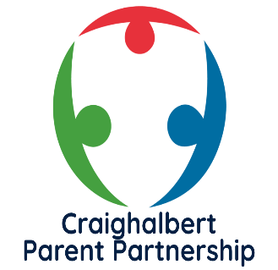  Craighalbert Parent Partnership  Parent Partnership | Craighalbert | What the project offers  The Craighalbert Parent Partnership is a welcoming community of parents and carers who come together to support one another, share lived experience, and help strengthen the connection between families and the Craighalbert Centre.  We organise monthly craft mornings, coffee mornings, and wellbeing sessions designed to give families space to relax, recharge, and meet others who understand the unique challenges and joys of caring for a child with complex needs.  Each session aims to offer: A friendly listening ear, peer support from families with lived experience, Information from relevant charities and organisations and also allow for activities that create a calming environment that help carers take a breath.  All events will be advertised through our website, email updates, and the Craighalbert Centre’s social media channels, making it easy for families to stay connected and get involved.  At the heart of the Parent Partnership is a simple aim: to build a supportive, empowered community where every family feels heard, valued, and never alone. | Main referral details  Contact Lynsey McLuckie at parentcouncil@craighalbert.org.uk  Location(s) of service provided  The Craighalbert Centre, 1 Craighalbert Way, Cumbernauld, G68 0LS  Who service is available to  To all parent carers of any age to a child with complex health, communication and care needs
  Kinship Connect  https://www.facebook.com/KinshipLanarkshrie | What the project offers  Kinship Connect Lanarkshire is a friendly, volunteer-led support group for kinship carers and the children they care for across Wishaw and the surrounding area. We provide a safe, welcoming space where carers can connect with others who understand their situation, share experiences, and access support without judgement.  We host regular peer support sessions where carers can come along for a chat, a cuppa, and a bit of breathing space. These sessions help reduce isolation, build friendships, and provide emotional support in a relaxed and informal setting.  We offer dedicated, wellbeing sessions focused on supporting carers’ mental health and overall wellbeing. These sessions are designed to give carers time for themselves, helping to reduce stress and build resilience.  We organise group activities and outings for kinship families, giving children the opportunity to socialise with others in similar situations while creating positive shared experiences. These activities help strengthen family relationships and promote inclusion.  We provide access to information around financial support, services, and local resources. Where needed, we can signpost or support referrals to relevant organisations to ensure carers receive the help to which they are entitled.  Our group supports both formal and informal kinship carers, recognising that many families take on caring roles unexpectedly and may not be connected to statutory services.  At the heart of everything we do is a simple aim:  To ensure kinship carers feel supported, valued, and part of a community. | Main referral details  Contact Claire Mason at kinshipconnectlanarkshire@gmail.com  Location(s) of service provided  Wishaw Library – Community Room  Who service is available to  All kinship carers and extended family of kinship carers who provide a supporting role to the looked after child within North Lanarkshire
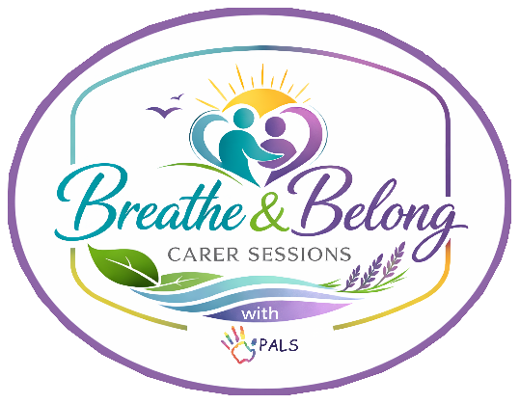  PALS (Play and Learning Support)  www.playandlearningsupport.co.uk | Breathe & Belong – We Care Because You Care  The Breathe & Belong programme will offer regular, restorative sessions that create protected time for carers to pause, regulate, reconnect with themselves, and build supportive peer relationships.  What the project offers:  - Monthly carer sessions (wellbeing sessions, creative activities, sports, and peer support groups) and information sessions from specialist organisations.  - Quarterly connection/social sessions including tea/coffee breaks to strengthen peer relationships and reduce isolation.  - Bi-annual respite sessions, where the children are invited to a movie or pjs party session staffed by PALS volunteers and staff, to allow carers to have 2 hours of time to themselves.  - Annual celebration lunch – to review Breathe & Belong and celebrate our carers. | Main referral details:  Contact Fiona Michie at  info@playandlearningsupport.co.uk  Location(s) of service provided:  Various locations in Cumbernauld and the surrounding area.  Who service is available to:  All carers of children and young people with additional support needs in North Lanarkshire.
  Shotts Bon Accord Walking Football  https://www.facebook.com/p/Shotts-Bon-Accord-walking-football-61577625905140/ | What the project offers  Extra Time for You is a free, monthly Saturday session for male carers aged 40+, offering a relaxed hour of walking football followed by an hour of social time with refreshments and lunch. It’s a friendly, non-competitive space designed to support wellbeing, reduce stress, and give carers a meaningful break from their caring role.  Carers can attend in whatever way suits them best – on their own, with the person they care for, or alongside family – making it flexible, welcoming, and pressure-free. The sessions also offer a chance to connect with others, build friendships, and access information about wider support available to carers. | Contact Craig Bridges at sbawalkingfootball@gmail.com  Location(s) of service provided  Calderhead High School, Dyfrig Street, Shotts, ML7 4DH  Who service is available to  Males aged 40+ anywhere across North Lanarkshire who are unpaid carers, family carers or caring for anyone with disabilities
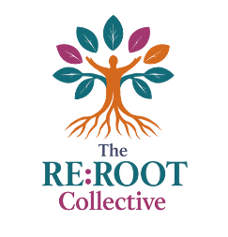  The Re:ROOT Collective | What the project offers  - Sound Bathing  - Creative Reuse  - Art and Nature Connection | Main Referral Details  Contact Emma Ferla at thererootcollective@gmail.com  Location(s) of service provided  Newmains (address tbc)  Who service is available to  Unpaid carers within the Wishaw and Shotts locality
  Womens Activeworks Society  https://www.instagram.com/womenactiveworkssociety?igsh=MWs2ZGYyeThvYnVmea== | What the project offers  - Monthly peer support sessions providing a safe space for carers to relax, connect and share experiences and focus on their wellbeing  - Creative wellbeing workshops including journaling, painting, and crafts  - Nature-based activities such as guided walks and outdoor wellbeing sessions  - Guest speakers offering advice, information, and signposting to support services | Main Referral Details  Contact at Uzma Yousaf at Lanarkshire Mosque  Location(s) of service provided  Lanarkshire Mosque, 3 Clydesdale Street, New Stevenson, ML4 2RS  Who service is available to  Children of ethnic minorities with additional support needs.

Please do not hesitate to call our Team at NLCT on 01698 404055 or
Email: enquiries@carerstogether.org
If you require any more information.

